## Basics

* operating System

### History

Ken Thompson early 70s UNIX

MULTICS

UNICS

UNIX

UNIX 1975

system V

Linus Torvalds early 90s Linux

Richard Stallman

Next – Darwin

### Open source

1. sell the ice cream , hide recipe
2. sell the ice cream, recipe public
3. free ice cream on sunday, hide the recipe
4. free ice cream on sunday, recipe public

source code open

firefox

VLC

GIMP

Blender

Audacity

Wordpress

Linux

### standards

sysV

BSD

### Unix based systems

Darwin

Solaris

AIX

HP-UX

Xenix

FreeBSD

### Linux based systems

kernel

GNU open source

Red Hat Linux 1994

Linux Mint

Fedora Core

OpenSuse

Debian Linux

Elementary OS

Kali Linux

Ubuntu Linux

BOSS

unix-like & Linux

## architecture

### kernel

* process management
  + creation
  + scheduling
  + termination
* memory management
  + allocation
* device drivers
  + communication between OS & hardware
* systems calls
  + user applications & kernel interactions

### system library

* special functions
* applications use to perform system-related tasks
* glibc

### system utilities

ls

cp

grep

ifconfig

top

### user applications

web browsers

office suites

text editors

games

### shell

cli

### File system structure

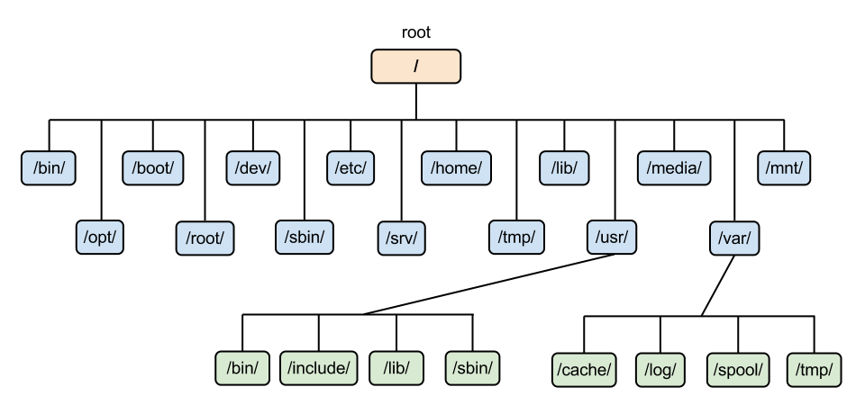

inverted tree structure

/ <root>

/bin

/home/john

/bin essential command binaries

/etc configuration files

/home user home directories

/lib essential shared libraries & kernel modules

/usr user utilities & applications

/var variable data files (logs, databases etc)

/dev device driver files

### Bootloader

GRUB

LILO

## shell

terminal

command line interpreter

CLI

### types

sh

ksh

csh tcsh

zsh

Fish

bash

### prompt

username@hostname ~ $

$ regular user

# root user

### command (structure)

ls

ls -l

ls -l /home/john/Desktop

command options arguments

command arguments options

### wild cards

#### character substitution

* many characters

? single characters

[ ] specific or set of characters

## basic commands

ls

-l long listing

more info

-a all

-h size in terms of k/m/g

-i inode number

dir

clear

cleared the screen

pwd

print working directory

date

cal

bc

cd

exit

### help

#### whatis

#### man

man ls

b

f

search

/sss searches for text sss within the man page

n next

shift + n previous

pages

1 commands

2 system calls

3 library calls (functions)

printf() exit()

4 special files

usually /dev

5 file formats & conventions

6 games

7 misc

signals

8 system admin

#### help

## misc commands

### alias

alias

unalias

### other commands

hostname

uname

history

shutdown

basename

dirname

unlink

remove a file

### find

-name

-type

d

f

-perm

### combining commands

pipe |

## grep

-n

-i

-v

-w

### patterns (regular expressions)

^ matches the beginning of a line

[ ] matches any of the enclosed characters

{ } specifies number of occurrences of the preceding element

\{ \}

{x, y} min x occurrences

max y occurrences

{x, } min x occurrences

max any occurrences

$ matches the end of line

## files and directories

* basic unit of data storage

text files

.txt

.c .py .cpp

binary files

bin under /usr

files/directories starting with .

* hidden

### paths

relative path

absolute path

### general commands

cd

.. parent

cd ..

<name>

cd john

~ home directory

- previous directory

. current directory

pwd

mkdir

rmdir (only if its an empty folder)

wc

-c characters

-w words

-l lines

### viewing files

cat

nl

less

more

head

tail

more

### other file commands

cp copying

mv moving

renaming

rm removing a file

removing a directory

-r recursive

-i prompts before every removal

-f forceful

-v verbose

touch

### inode

ls -i

### links

hard links

symbolic (short, soft) links

* like shortcuts

## editors

vi (vim)

gedit

atom

emacs

notepad++

### vi

insertion mode

i

command mode

esc

:w save

:wq save & quit

:q! quit without saving

:w! save as

:w! extended_beatles.txt

yy copy

6yy copies 6 lines

p pasting

dd cut a line

delete a line

2dd cut 2 lines

u undo

### redirection

>

>>

## Users and Groups

* every user belongs to a group

### superuser

root

full read/write privileges

creating or installing files or software

modify settings

creating/deleting users/data

yearly_trainings.data 764

| permissions | | |
| --- | --- | --- |
| u | g | o |
| bhadra | training | others |
| read write executable | read write ~~executable~~ | read ~~write~~ ~~executable~~ |
| rwx | rw- | r- - |
| 111 | 110 | 100 |
| 7 | 6 | 4 |

user group others

chmod

u g o

664

rwx

chown

change user of a file

chgrp

change group of a file

umask

change the way default permissions for a file are generated

who

whoami

useradd

groupadd

passwd

usermod

## memory and storage

du disk usage

-h human readable

stat

df

disk free

-k show in kilobytes

-h human readable

## environment variables

echo $SHELL

SHELL

LOGNAME

PATH

MANPATH

HISTSIZE